Jack Crawford

1052

31 January, 2018

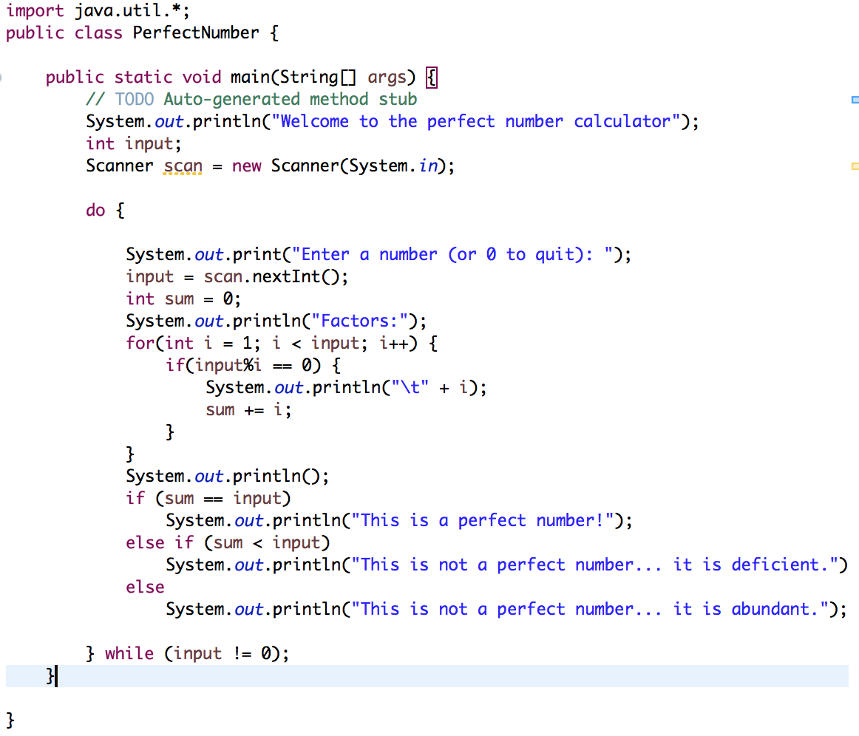

Output:

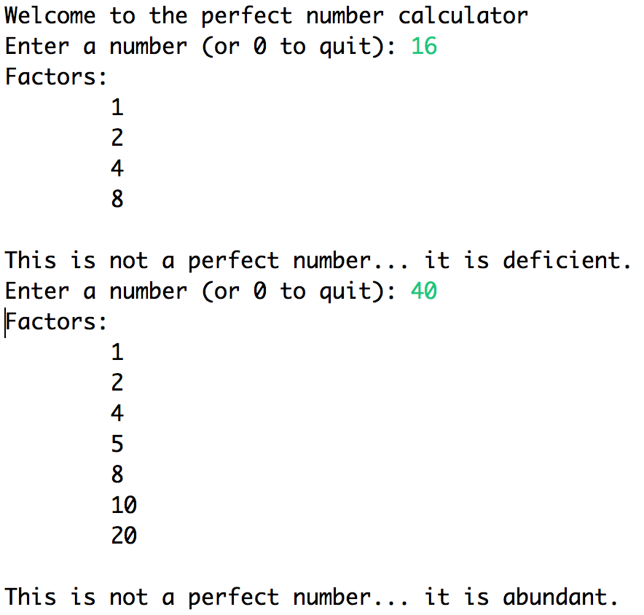

Fun assignment!!